**Minitab 14.12 Installation Procedure in Microsoft Window 10**

1. Run the “Minitab Setup.exe” and click on the “Next”.

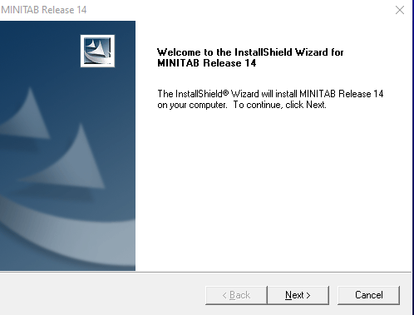

1. Read and accept the terms of the license agreement and click “Yes”.

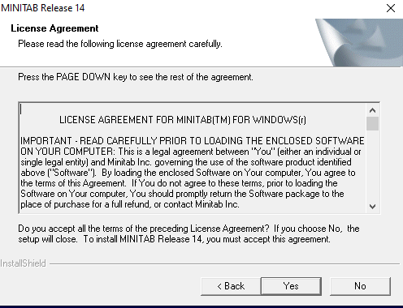

1. Enter the “Serial Number” and click “Next”.

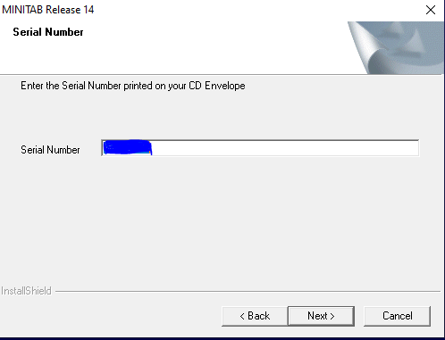

1. Choose the Destination Location by Default and click “Next” button.

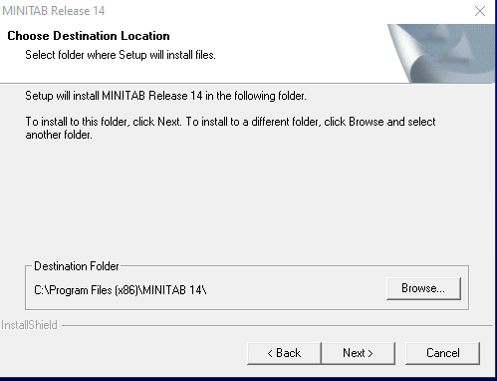

1. Now Select the Setup type we choose complete and click “Next”

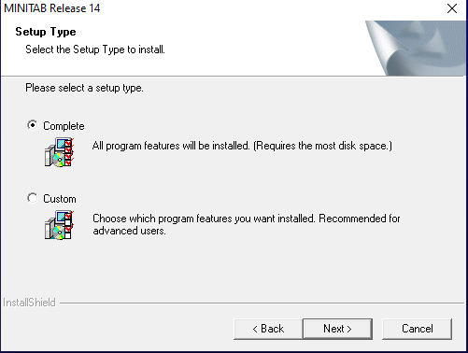

1. Select the program folder and click on “Next”.

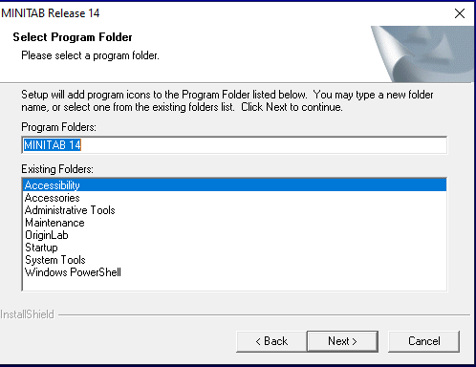

1. Start copying files and click “Next”.

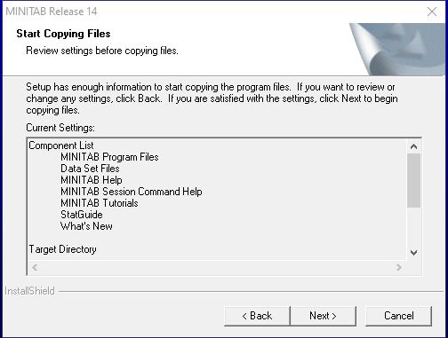

1. The installer will proceed to complete the installation wait a few second.

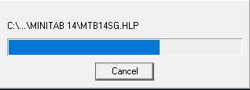

1. Ask do you like to install a Minitab icon on desktop. Click on “Yes”

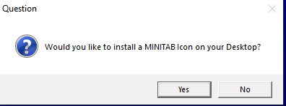

1. Click “Finish” to complete the installation and uncheck the check box

